
Story

Date | 20 September 2026
Team ID | Roll 58
Project Name | EV Market Analysis Dashboard using Tableau Public
Maximum Marks | 5 Marks

Using a Tableau Story, the EV Market Analysis Dashboard presents key patterns in the ev_market_train dataset through a sequence of interactive visualisations. The story guides viewers from an overall market summary to sales performance, battery technology, price and range, customer ratings, and sustainability/geographic insights.
Each story point should contain a relevant worksheet or dashboard and a short caption explaining the business question. Use filters and tooltips where helpful. Report only patterns verified in Tableau; do not assume the dataset represents the entire EV market or that a relationship between two measures proves causation.
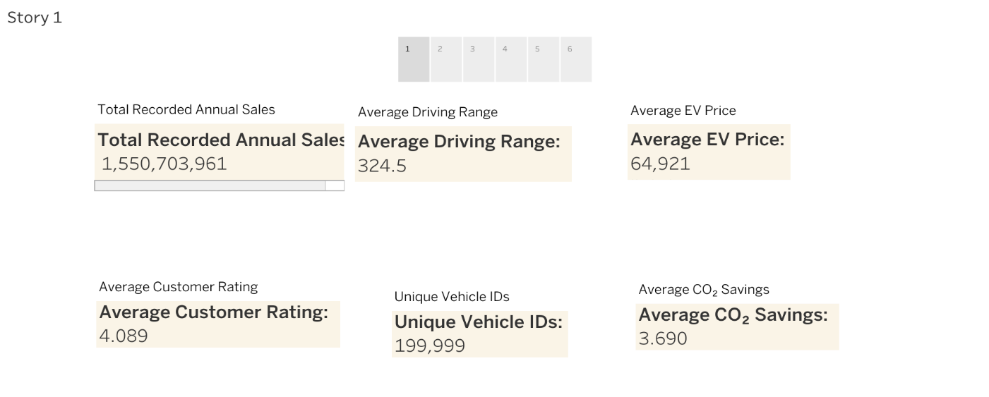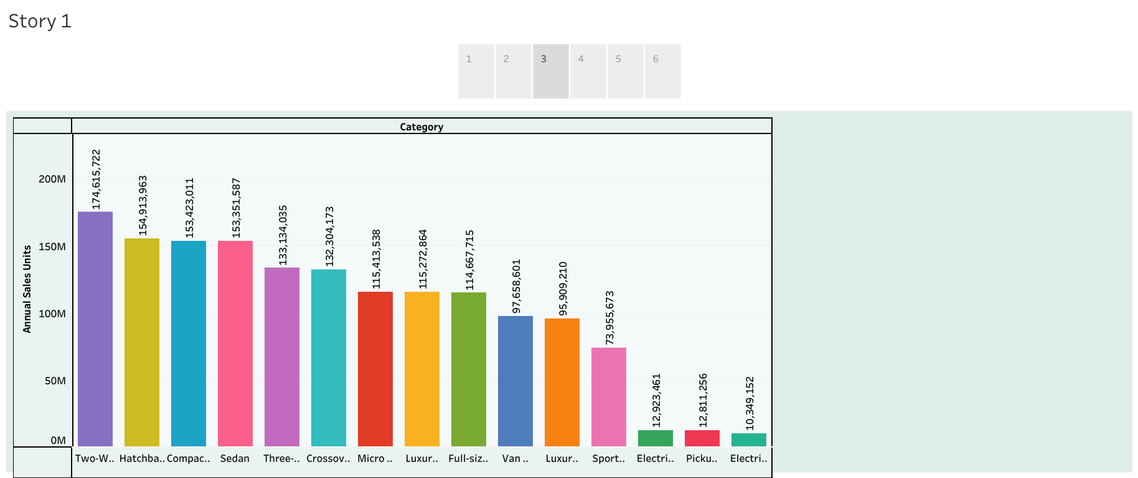

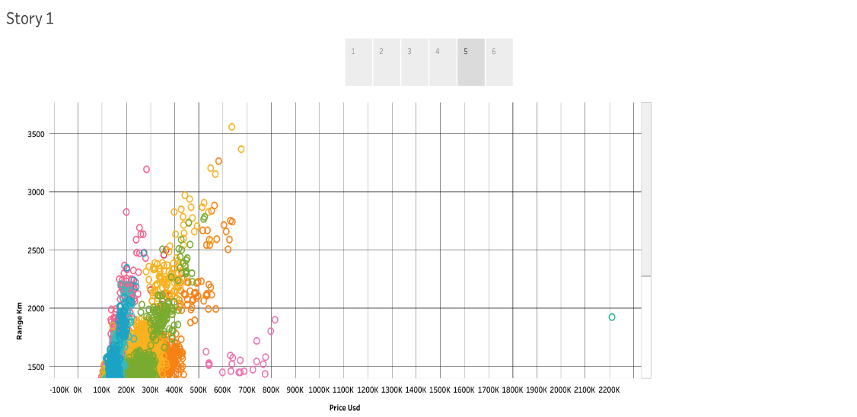

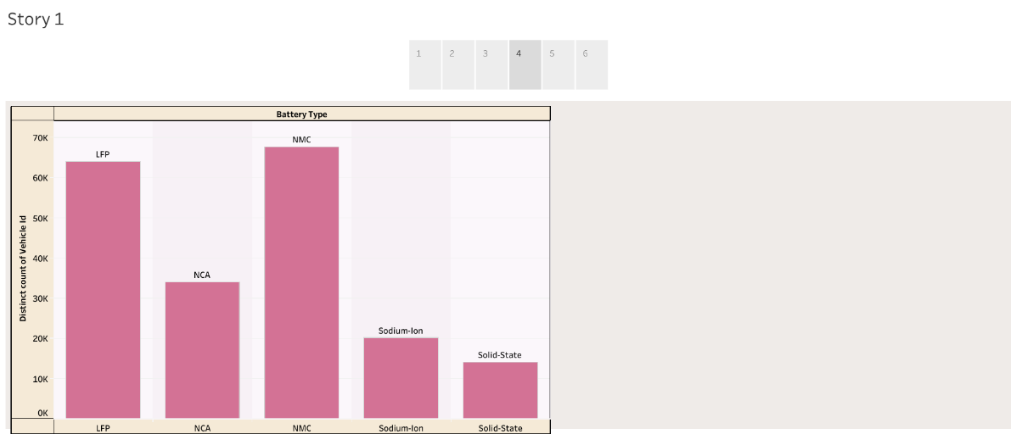
Observations / Story Points:
- 1. EV Market Overview: Use KPI cards for total recorded annual sales, average price, average driving range, and average customer rating. These KPIs establish the baseline for the analysis; insert the verified values from Tableau.
- 2. Manufacturer and Category Performance: Use horizontal and category bar charts to compare SUM(annual_sales_units) by manufacturer and vehicle category. Identify the highest and lowest groups only after checking the sorted chart.
- 3. Battery Technology and Vehicle Performance: Use a bar chart for the distribution of battery_type, then compare range_km and efficiency_wh_per_km by category if those fields are available and valid. Clarify whether the chart counts records or sums sales.
- 4. Price, Customer Ratings, and Sustainability: Use a scatter plot of price_usd against range_km, colour by category, and a bar chart for AVG(customer_rating) by manufacturer. Add a final view for co2_saved_tons_per_year or manufacturing_country/market_region. Write the final insight after checking the actual chart results.

Activity 2:Publish Story on Tableau Public and paste the public link below
https://public.tableau.com/views/EV_market_train/Story1?:language=en-US&publish=yes&:sid=&:redirect=auth&:display_count=n&:origin=viz_share_link

